**WELL LOG FACIES ANALYSIS & CLASSIFICATION USING MACHINE LEARNING TECHNIQUES**

Name :- L Akhilesh

Roll No :- 200107045

Submission Date :- 30/03/2024

Course :- CL 653; AI-ML In Chemical Engineering

Correlation Matrix Obtained:

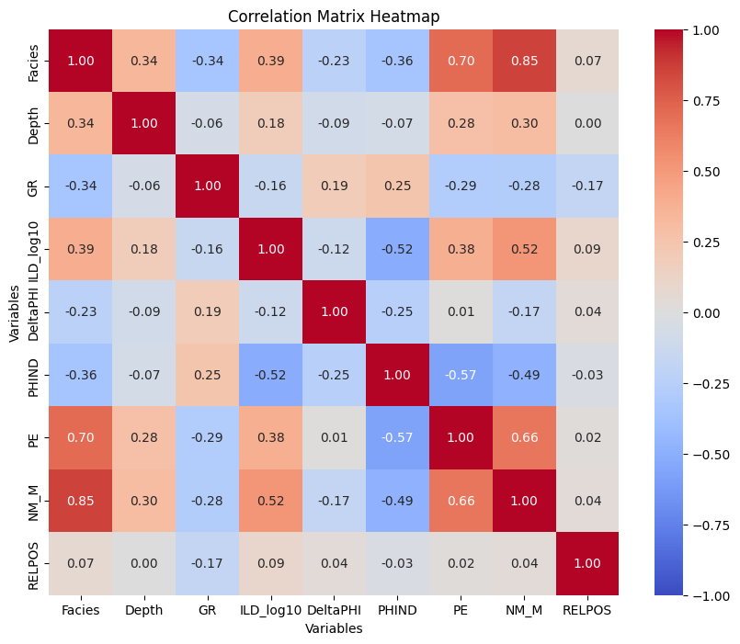

From this it can be observed that the best target label(facies) belongs to NM_M with close to 85% and PE with 70% in agreement.

## **Machine Learning Models Implemented:**

* Random Forest
* SVM
* KNN
* Logistic Regression
* Naïve Bayes

# **Random Forest:**

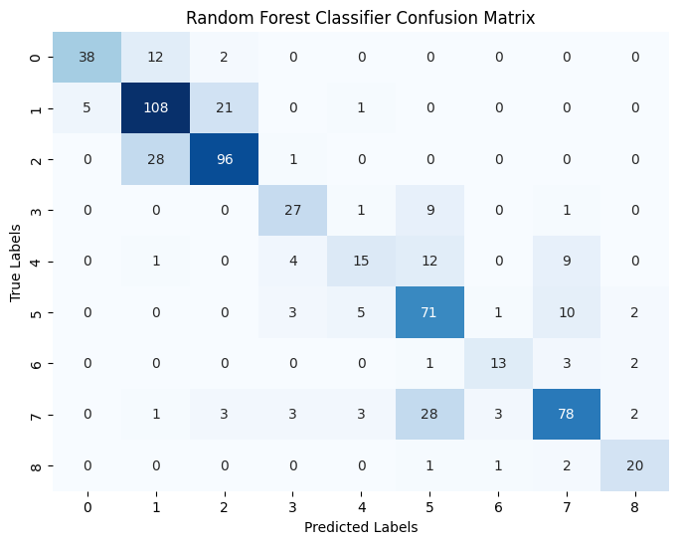F1 score of 0.718 was obtained. The confusion matrix shown below was obtained:

# **SVM:**

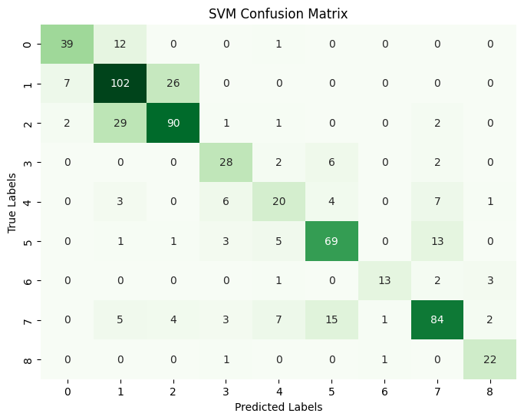 F1 score of 0.721 was obtained. The confusion matrix shown below:

# **KNN:**

F1 score of 0.703 was obtained. The confusion matrix shown below:

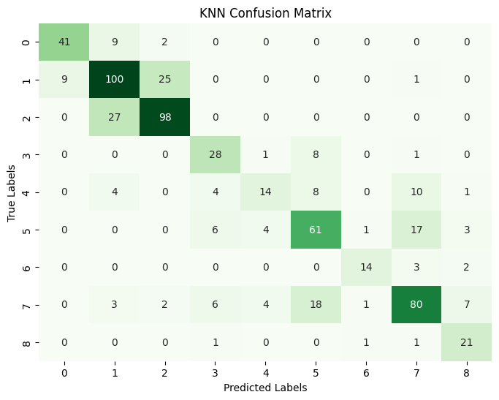

# **Logistic Regression:**

F1 score of 0.586 was obtained. The confusion matrix shown below:

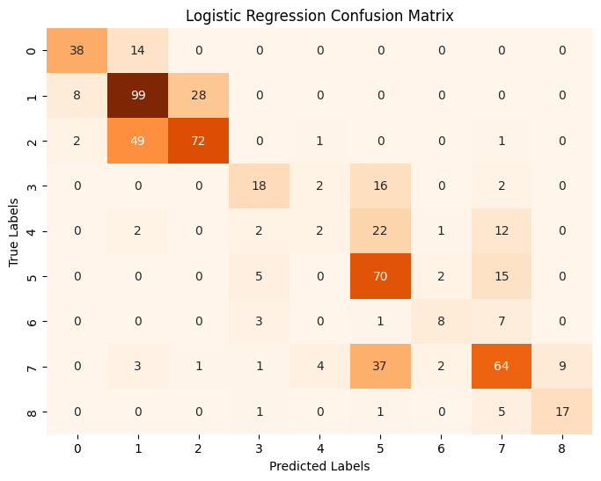

# **Naïve Bayes:**

F1 score of 0.118 was obtained. The confusion matrix shown below:

